Initial prompt asking for the top 10 books in the world.

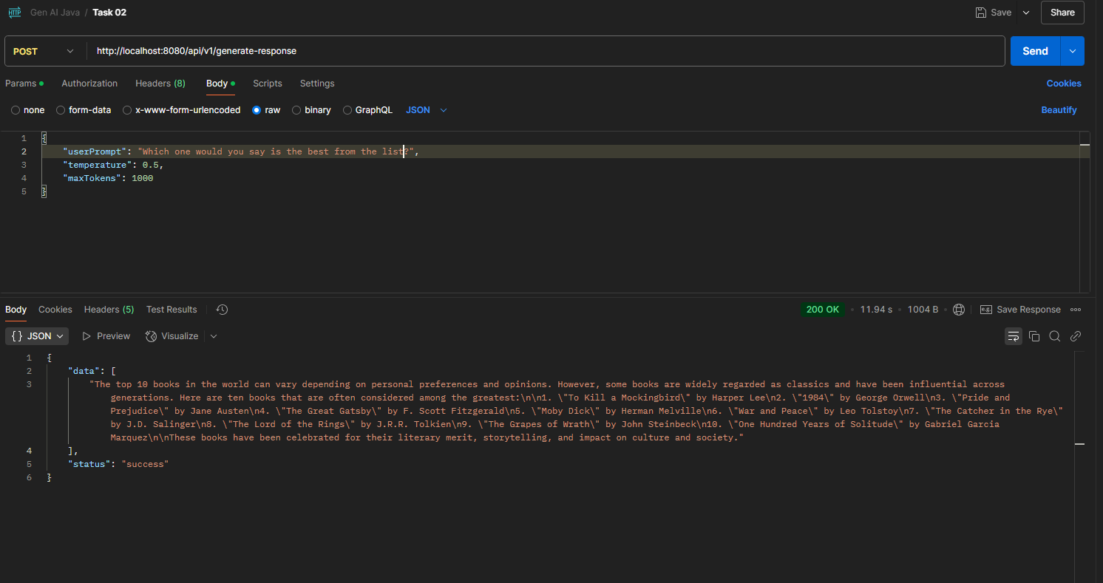

Based on above response, asked Ais opinion on which one is the best?

The AI was able to remember the context of the question based on previous prompt.

Again, probed which one apart from the one listed in previous response is good.

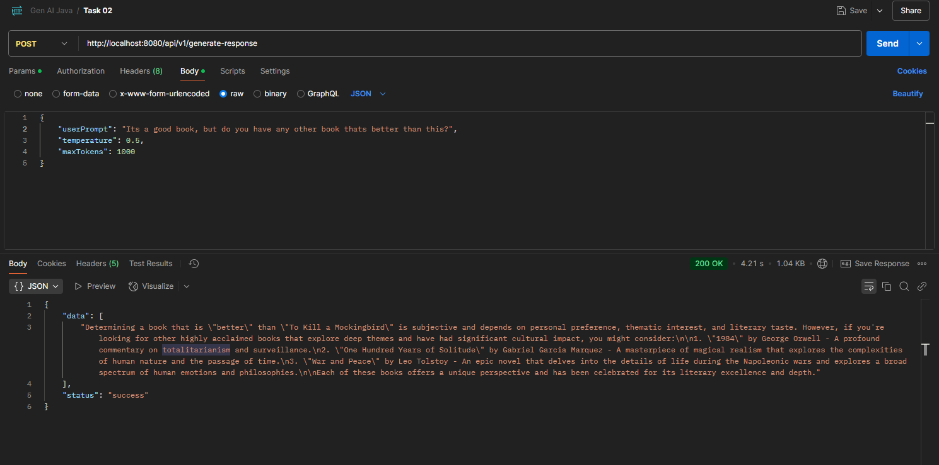

Some console screenshots



Different responses based on experimenting with different values of temperature and max tokens.

